April is …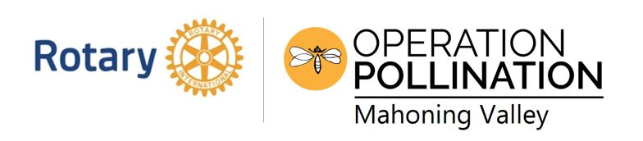
Ohio Native Plant Month!

April 20 - Earth Day at YSU Kilcawley Center 10:00 – 3:00

April 23 - Mill Creek MetroParks cleanup day - 40 locations!

Soil & Water Conservation District Spring Sale!

April 27 - Plant a Seed Event at the PLYMC Canfield Library https://libraryvisit.libnet.info/event/6218430
